Project Design Phase
Solution Architecture
Date | 20 July 2026
Team ID
Project Name | Plugging Into the Future: An Exploration of Electricity Consumption Patterns
Maximum Marks | 4 Marks

Solution Architecture Diagram
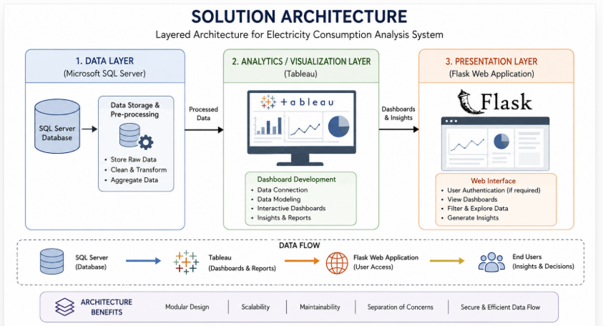

Architecture Description
The architecture follows a layered design: a Data Layer (Microsoft SQL Server) for storage and pre-processing, an Analytics/Visualization Layer (Tableau) for building dashboards, and a Presentation Layer (Flask) for web-based access. Each layer communicates in one direction — data flows from the database to the visualization layer, and from there into the web application — keeping the system modular and easy to maintain.

